1. Go to <http://10.27.1.170:9494/default.aspx> and login your credential

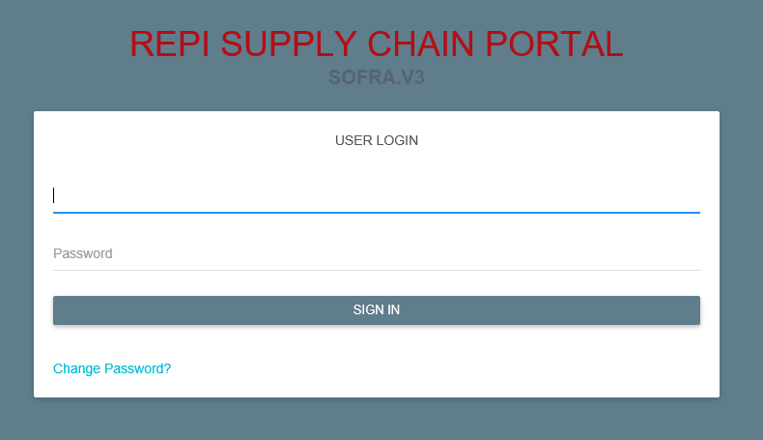

1. To create new request go to TERMINAL > Forwarder’s Evaluation > Transaction > Transaction Entry

Complete all the required fields before submitting the request.

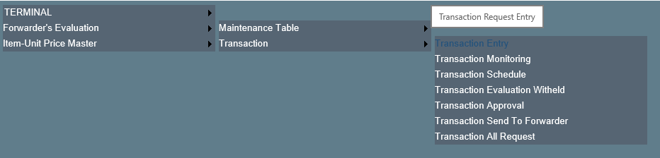

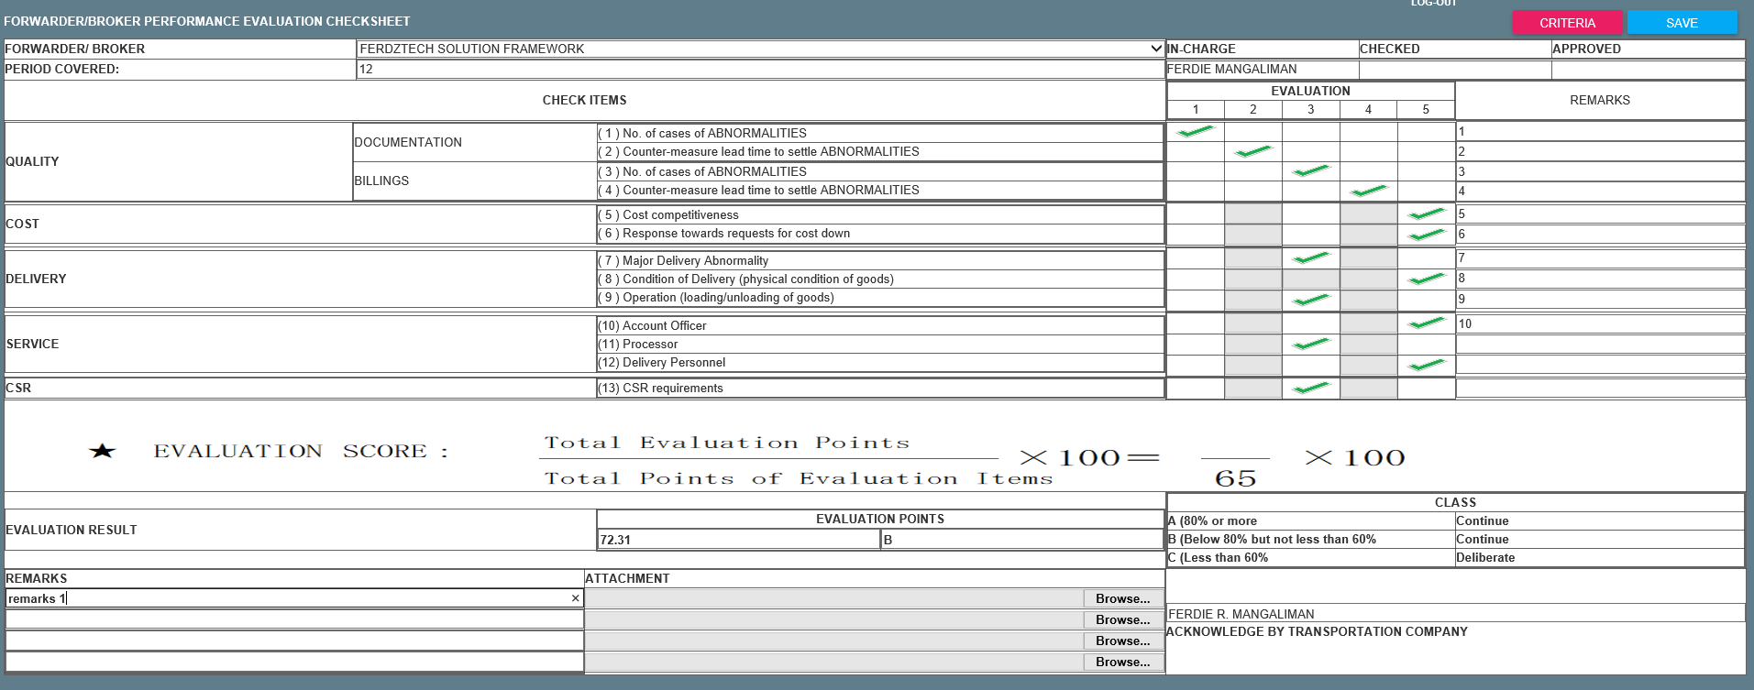

1. Click SAVE if you are done and it should be redirected to successful page if no issues.



1. To view Request go to TERMINAL > Forwarder’s Evaluation > Transaction > Transaction Monitoring

To see the details of the item, just click the DETAILS button

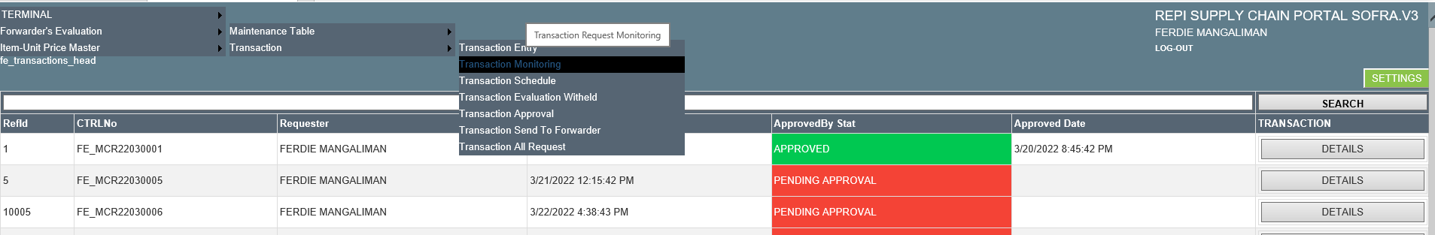

1. To view the schedule go to TERMINAL > Forwarder’s Evaluation > Transaction > Transaction Schedule

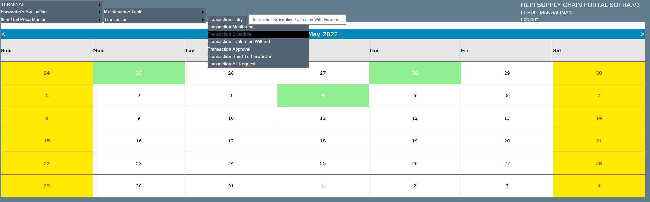

To view the schedule details, just click the dates with green background and it will display the schedule details.

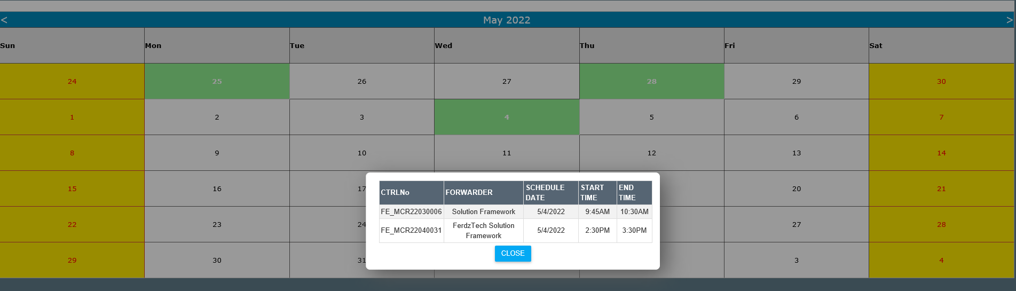

1. To view the Transaction Evaluation Witheld go to TERMINAL > Forwarder’s Evaluation > Transaction > Transaction Evaluation Witheld

To view the details, just click the DETAILS button.

To start the discussion with the Broker, just click the START DISCUSSION button

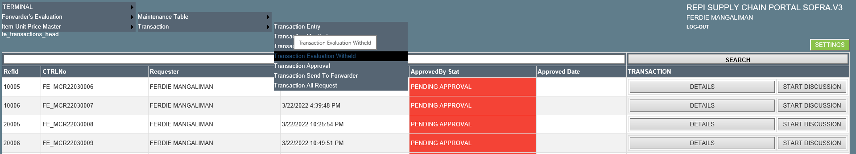

1. To view the Transaction Approval go to TERMINAL > Forwarder’s Evaluation > Transaction > Transaction Approval

Details of all transactions will display. If you want to approve item, click the DETAILS button to display all the details of the specific item.

Approver is able to review, schedule, approve and disapprove the request.

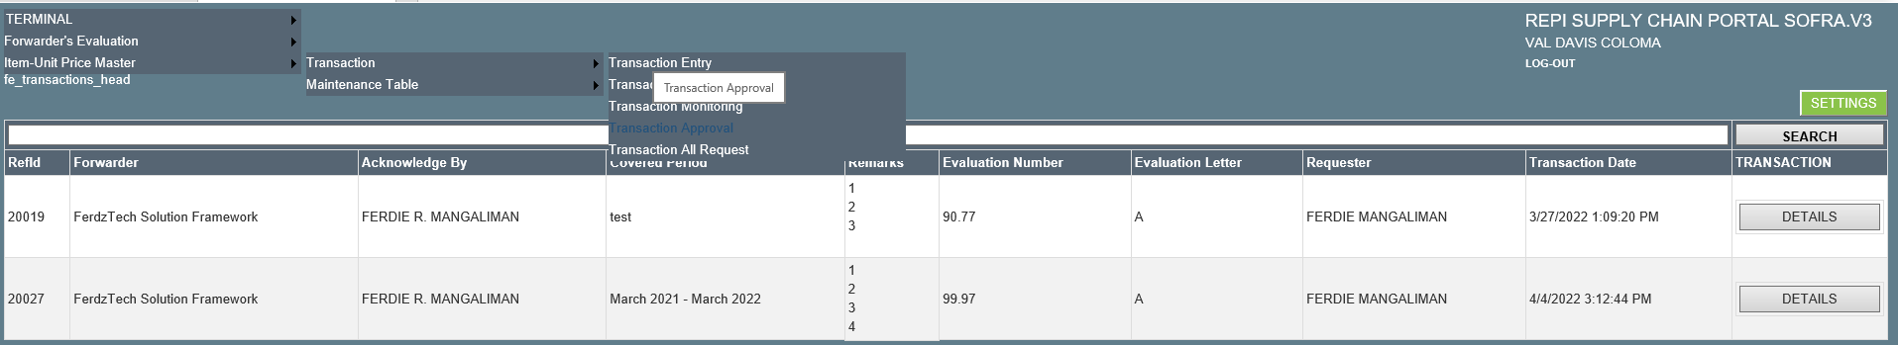

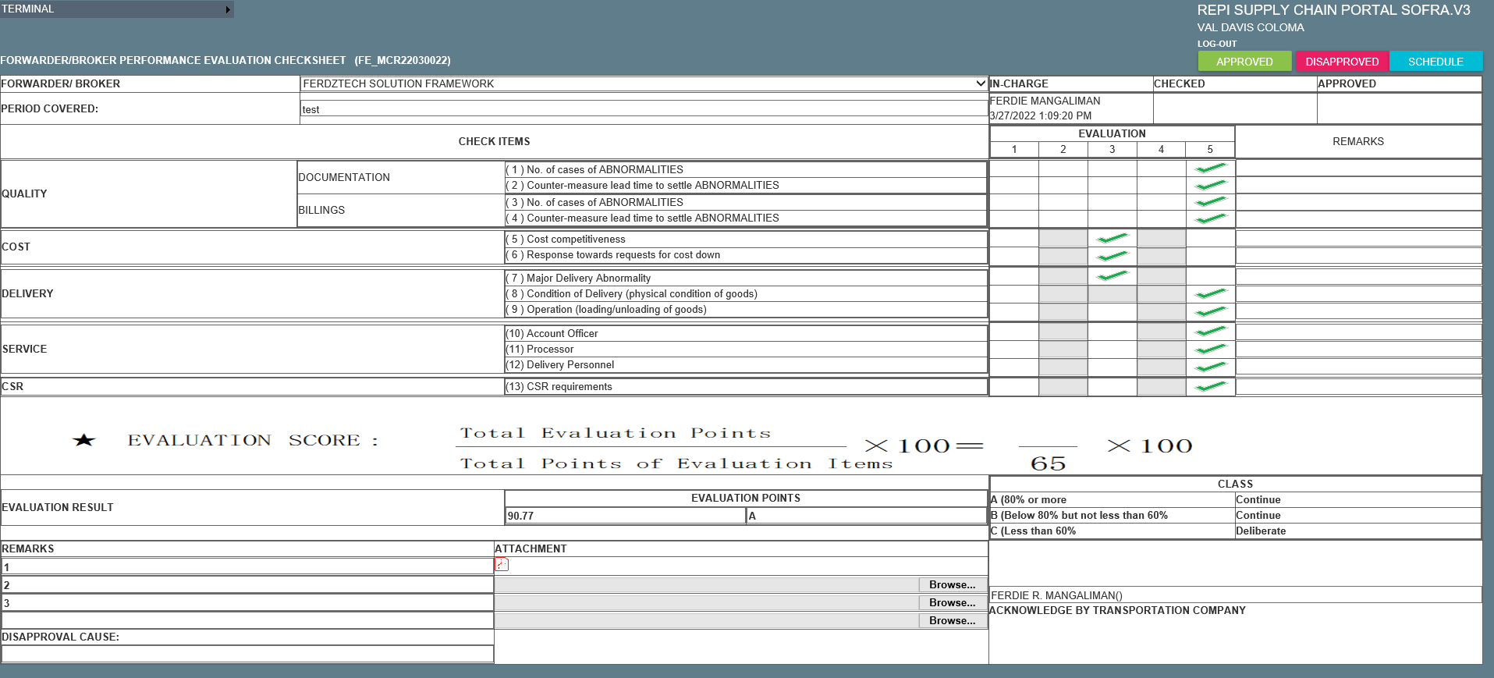

1. To view the Transaction Send to Forwarder go to TERMINAL > Forwarder’s Evaluation > Transaction > Transaction Send To Forwarder

To send the result to broker, just click the SEND TO FORWARDER button of specific item you want to send.

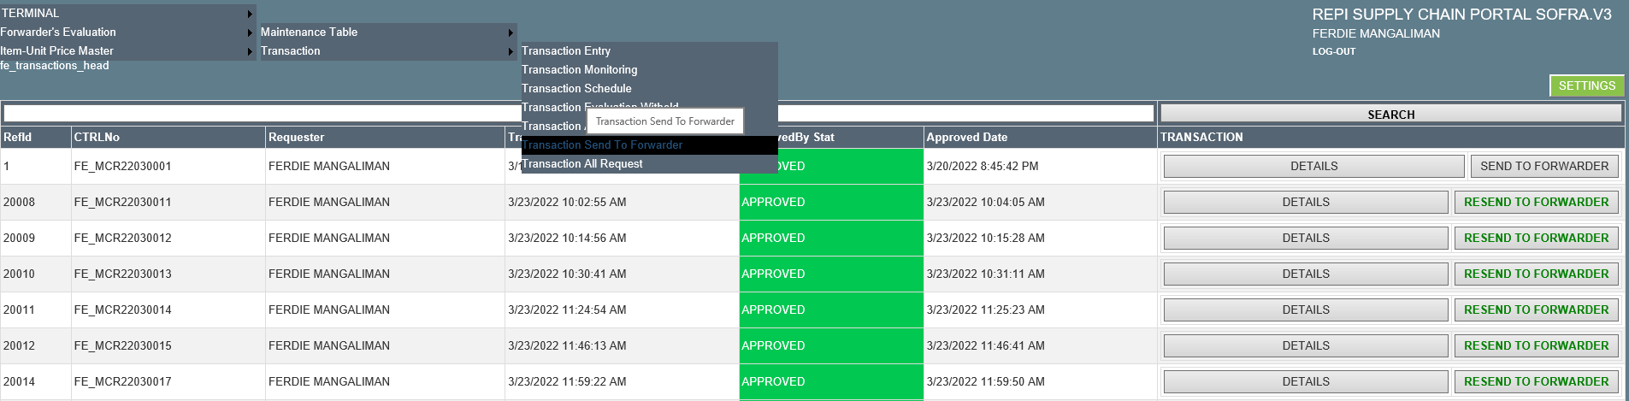

Broker will received and email with the attached HTML Evaluation Result.

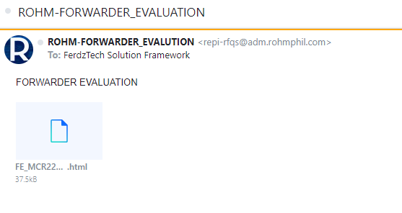

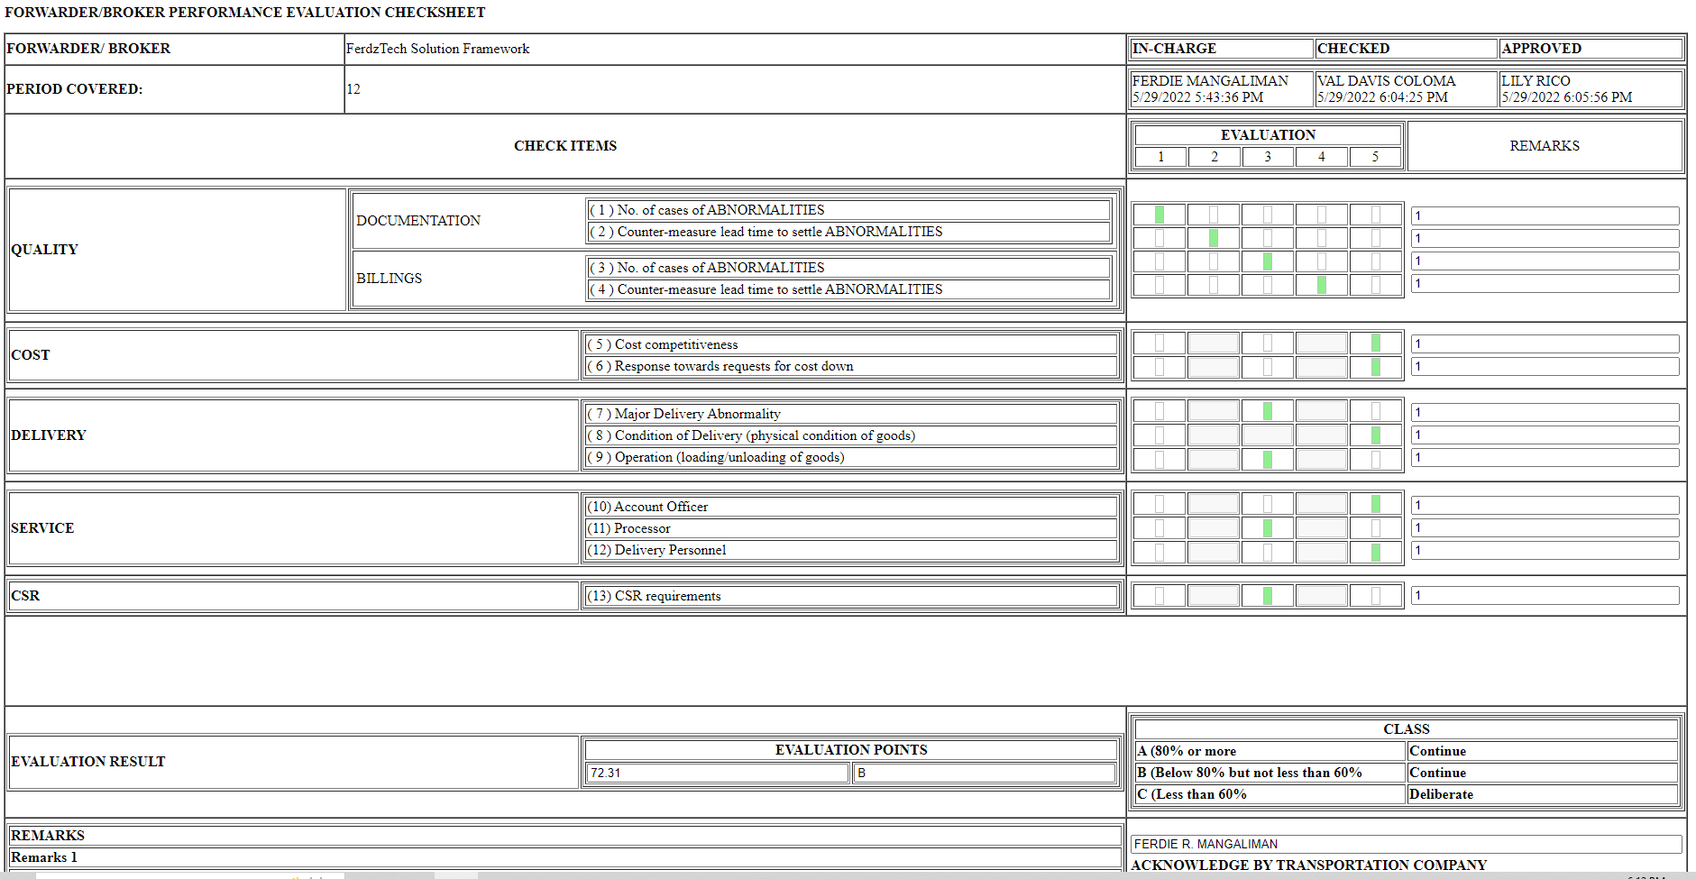

1. To view the Transaction Approval go to TERMINAL > Forwarder’s Evaluation > Transaction > Transaction All Request

To view the details, just click the DETAILS button

